Pi Pico Installation and setup C/C++ Sdk
Global Installation steps
- Install the below tools, And while Installing add their path to environment variables
- CMake - https://cmake.org/download/
- Git -
- ARM GCC Toolchain - https://developer.arm.com/downloads/-/arm-gnu-toolchain-downloads
arm-gnu-toolchain-14.3.rel1-mingw-w64-i686-arm-none-eabi.exe
- Git
- Python
- Mingw-W64 - ( instead of build tools for visual studio 2019) -
https://www.youtube.com/watch?v=oC69vlWofJQ
https://code.visualstudio.com/docs/cpp/config-mingw
  - In MYSYS2 shell run
> pacman -S --needed base-devel mingw-w64-ucrt-x86_64-toolchain
  - Edit the PATH variable (user env variable)and add:
C:\msys64\ucrt64\bin
  - Verify installation – open cmd and run
> gcc –version
> g++ --version
> mingw32-make --version
- Cloning pico-sdk from github: https://github.com/raspberrypi/pico-sdk.git
> git clone -b master https://github.com/raspberrypi/pico-sdk.git
> cd pico-sdk
> git submodule update –init
optional steps to download pico-examples
> cd ..
> git clone -b master https://github.com/raspberrypi/pico-examples.git

- Add pico-sdk path to environment variables
Under User variables add Path
Variable name: PICO_SDK_PATH
Variable value: E:\Embedded\pi_pico\pico-sdk
- Creating the first project blink led and building it using the sdk
- To build pico-examples
- Clone pico examples: > git clone -b master https://github.com/raspberrypi/pico-examples.git
> cd pico-examples
> mkdir build
> cd build
- For Mingw-W64 setup
> cmake -G "MinGW Makefiles" ..
> mingw32-make
- For visual studio build tools setup(not required because I’m proceeding with Mingw)
> cmake -G "NMake Makefiles" ..
> nmake

- Windows installation refer: https://shawnhymel.com/2096/how-to-set-up-raspberry-pi-pico-c-c-toolchain-on-windows-with-vs-code/
- Linux Installation refer: https://circuitdigest.com/microcontroller-projects/how-to-program-raspberry-pi-pico-using-c
  - refer for setup file in: https://github.com/raspberrypi/pico-setup.git
Container based steps: Docker + Vs code editor
- Reference:
https://github.com/AppacYazilim/PicoDevEnv/tree/main
https://github.com/lukstep/raspberry-pi-pico-docker-sdk/tree/main
linux docker setup: https://youtu.be/CYBmfYR3Ti8?si=9-tBZ97tlwHwuIYE
- DockerFile
Dockerfile
# Base image with build essentials
FROM ubuntu:latest

# Install necessary packages
RUN apt-get update && apt-get install -y \
cmake \
gcc-arm-none-eabi \
libnewlib-arm-none-eabi \
libstdc++-arm-none-eabi-newlib \
git \
python3 \
g++ \
&& rm -rf /var/lib/apt/lists/*

# Set a default workspace
WORKDIR /workspace
- Devcontainer.json
{
"name": "Pico Dev Container",
"build": {
"dockerfile": "Dockerfile",
"context": ".."
},
"workspaceFolder": "/workspace",
"postCreateCommand": "git clone https://github.com/raspberrypi/pico-sdk.git && cd pico-sdk && git submodule update --init",
"customizations": {
"vscode": {
"extensions": [
"ms-vscode.cpptools",
"ms-vscode.cmake-tools"
]
}
}
}

- Steps to build
- Open Your Workspace in VS Code
- Rebuild or Open the Dev Container
  - 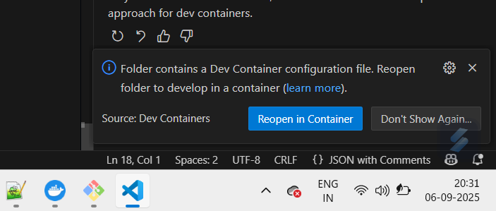
(OR)
How to rebuild or open the dev container in VS Code:
- Open VS Code.
- Open your project folder (that contains .devcontainer).
- Press Ctrl+Shift+P (or Cmd+Shift+P on Mac) to open the Command Palette.
- Type "Dev Containers: Rebuild Container" and select it.
  - This rebuilds the container from your Dockerfile and devcontainer.json (including reinstalling packages).
- Alternatively, if you haven't opened the folder in a container yet:
  - You will see an option to Reopen in Container; select it to launch the project inside the container.
- VS Code will then build or rebuild the container image, start the container, mount your workspace, and open a VS Code session connected to the container.
- Any terminals or commands you run inside VS Code now execute inside this isolated container.
Why do this?
- The container contains all your tools, libraries, and dependencies installed via the Dockerfile.
- Rebuilding applies any changes to your container environment.
- Opening inside the container gives you a consistent, reproducible dev environment across machines.
- Your code stays on your host machine but runs inside the container with full access.
- Make Sure Pico SDK is Cloned
Verify that pico-sdk exists in your workspace folder and that PICO_SDK_PATH is correctly set (it should be /workspace/pico-sdk).
- Edit or Add Your Project Source Code
Work on your C/C++ files and CMakeLists.txt inside your project folders (e.g., /workspace/001_blink/). Files ->add folder to workspace…
- Build Your Project
  - Open a terminal in VS Code (`Ctrl+``).
  - Navigate to your project directory (e.g., cd 001_blink).
> mkdir build
> cd build
- Run cmake to configure the project
> cmake ..
- Build the project:
> make
6. Locate Build Artifacts
- After building, the output files (.uf2, .elf, .bin) will be in your project’s build folder.
- These files are available in both the container and host filesystem for easy use and flashing.
7. Sync Code and Artifacts
- Any files or changes you make inside /workspace (container) will appear in your project folder on the host machine.
- You can use version control, drag-and-drop, or VS Code commands to sync, move, or copy build artifacts as needed.
- Files ->add folder to workspace…

Optional: > export PICO_SDK_PATH=/workspace/pico-sdk/
export PICO_SDK_PATH=/workspaces/pico_docker_env/pico-sdk
Standard Project Structure
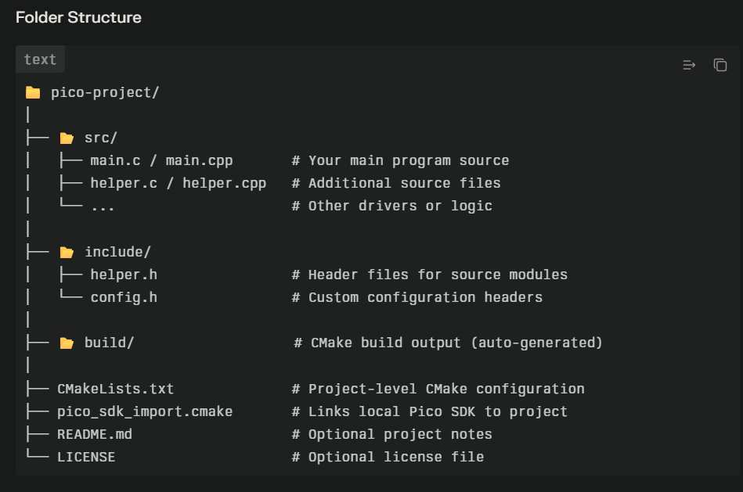
CMakeLists.txt
cmake_minimum_required(VERSION 3.13)
include(pico_sdk_import.cmake)

project(my_pico_project)
pico_sdk_init()

add_executable(my_pico_app
src/main.c
src/helper.c
)

target_include_directories(my_pico_app PRIVATE include)
target_link_libraries(my_pico_app pico_stdlib)

pico_add_extra_outputs(my_pico_app)

usage
# Set SDK path
export PICO_SDK_PATH=/path/to/pico-sdk

# Build project
mkdir build && cd build
cmake ..
make

Multicore
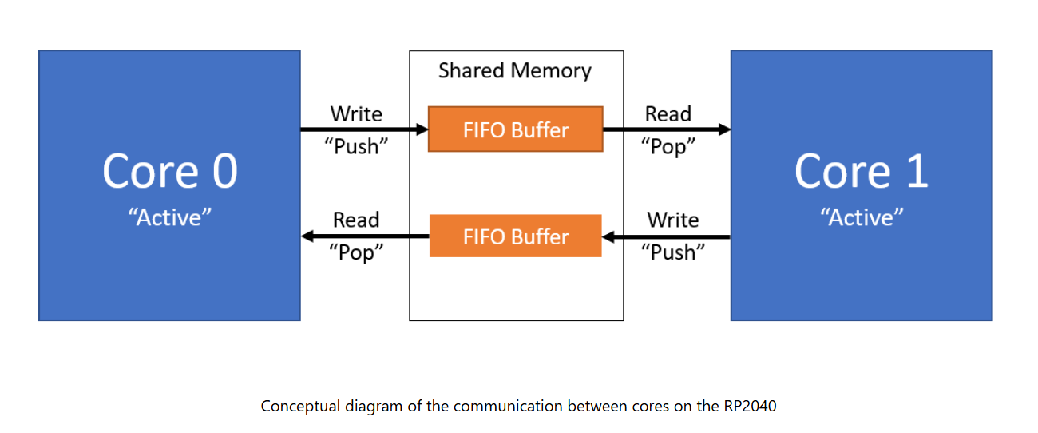

https://www.youtube.com/watch?v=aIFElaK14V4&list=PLEB5F4gTNK68IlRIJtcJ_2cW4dSdmreTw&index=7&t=311s
https://learnembeddedsystems.co.uk/basic-multicore-pico-example

I2C
    - Features
Each I2C controller is based on a configuration of the Synopsys DW_apb_i2c (v2.01) IP. The following features are supported:
- Master or Slave (Default to Master mode)
- Standard mode, Fast mode or Fast mode plus
- Default slave address 0x055
- Supports 10-bit addressing in Master mode
- 16-element transmit buffer
- 16-element receive buffer
- Can be driven from DMA
- Can generate interrupts

Check the sensor board schematics to check if the pullup resistors are included in the pcb board of the sensor itself
Pico SDK i2c most useful functions
- i2c_init
- i2c_write_blocking
- i2c_read_blocking

write operation -> i2c_write_blocking
read operation -> i2c_write_blocking and i2c_read_blocking(sends the address of specific register where we want to read and then reads from the register)

mpu6050 - I2C device found at address 0x68 !
bmp280 - I2C device found at address 0x76 !

FreeRTOS on the Raspberry Pi Pico (RP2040) - Step-by-Step FreeRTOS Setup

Step 1: Prerequisites
Ensure you have these installed:
On linux
> sudo apt install cmake gcc-arm-none-eabi build-essential git
On windows
- Pico SDK (already set up from your previous projects)
- CMake (3.13 or later)
- GCC ARM toolchain (arm-none-eabi-gcc)
- Git
Step 2: Download FreeRTOS Kernel
cd /pico_freertos_project
git clone https://github.com/FreeRTOS/FreeRTOS-Kernel.git
cd FreeRTOS-Kernel
git checkout main #Or specific version like V10.5.1

Step 3: Complete Project Structure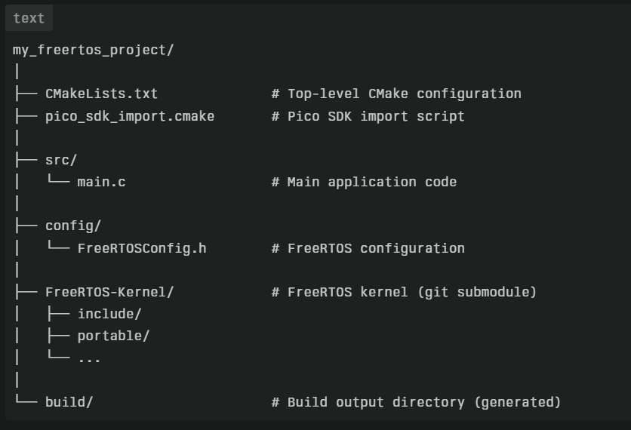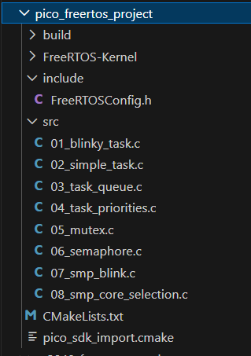

Step 4: Create FreeRTOSConfig.h - Location: config/FreeRTOSConfig.h
#ifndef FREERTOS_CONFIG_H
#define FREERTOS_CONFIG_H

/*-----------------------------------------------------------
* Application specific definitions.
*
* These definitions should be adjusted for your particular hardware and
* application requirements.
*
* THESE PARAMETERS ARE DESCRIBED WITHIN THE 'CONFIGURATION' SECTION OF THE
* FreeRTOS API DOCUMENTATION AVAILABLE ON THE FreeRTOS.org WEB SITE.
*
* See http://www.freertos.org/a00110.html
*----------------------------------------------------------*/

/* Scheduler Related */
#define configUSE_PREEMPTION 1
#define configUSE_TICKLESS_IDLE 0
#define configUSE_IDLE_HOOK 0
#define configUSE_TICK_HOOK 0
#define configTICK_RATE_HZ ( ( TickType_t ) 1000 )
#define configMAX_PRIORITIES 32
#define configMINIMAL_STACK_SIZE ( configSTACK_DEPTH_TYPE ) 256
#define configUSE_16_BIT_TICKS 0

#define configIDLE_SHOULD_YIELD 1

/* Synchronization Related */
#define configUSE_MUTEXES 1
#define configUSE_RECURSIVE_MUTEXES 1
#define configUSE_APPLICATION_TASK_TAG 0
#define configUSE_COUNTING_SEMAPHORES 1
#define configQUEUE_REGISTRY_SIZE 8
#define configUSE_QUEUE_SETS 1
#define configUSE_TIME_SLICING 1
#define configUSE_NEWLIB_REENTRANT 0
// todo need this for lwip FreeRTOS sys_arch to compile
#define configENABLE_BACKWARD_COMPATIBILITY 1
#define configNUM_THREAD_LOCAL_STORAGE_POINTERS 5

/* System */
#define configSTACK_DEPTH_TYPE uint32_t
#define configMESSAGE_BUFFER_LENGTH_TYPE size_t

/* Memory allocation related definitions. */
#define configSUPPORT_STATIC_ALLOCATION 0
#define configSUPPORT_DYNAMIC_ALLOCATION 1
#define configTOTAL_HEAP_SIZE (128*1024)
#define configAPPLICATION_ALLOCATED_HEAP 0

/* Hook function related definitions. */
#define configCHECK_FOR_STACK_OVERFLOW 0
#define configUSE_MALLOC_FAILED_HOOK 0
#define configUSE_DAEMON_TASK_STARTUP_HOOK 0

/* Run time and task stats gathering related definitions. */
#define configGENERATE_RUN_TIME_STATS 0
#define configUSE_TRACE_FACILITY 1
#define configUSE_STATS_FORMATTING_FUNCTIONS 0

/* Co-routine related definitions. */
#define configUSE_CO_ROUTINES 0
#define configMAX_CO_ROUTINE_PRIORITIES 1

/* Software timer related definitions. */
#define configUSE_TIMERS 1
#define configTIMER_TASK_PRIORITY ( configMAX_PRIORITIES - 1 )
#define configTIMER_QUEUE_LENGTH 10
#define configTIMER_TASK_STACK_DEPTH 1024

/* Interrupt nesting behaviour configuration. */
/*
#define configKERNEL_INTERRUPT_PRIORITY [dependent of processor]
#define configMAX_SYSCALL_INTERRUPT_PRIORITY [dependent on processor and application]
#define configMAX_API_CALL_INTERRUPT_PRIORITY [dependent on processor and application]
*/

#if FREE_RTOS_KERNEL_SMP // set by the RP2040 SMP port of FreeRTOS
/* SMP port only */
#define configNUMBER_OF_CORES 2
#define configTICK_CORE 0
#define configRUN_MULTIPLE_PRIORITIES 1
#define configUSE_CORE_AFFINITY 1
#define configUSE_PASSIVE_IDLE_HOOK 0
#endif

/* RP2040 specific */
#define configSUPPORT_PICO_SYNC_INTEROP 1
#define configSUPPORT_PICO_TIME_INTEROP 1

#include <assert.h>
/* Define to trap errors during development. */
#define configASSERT(x) assert(x)

/* Set the following definitions to 1 to include the API function, or zero
to exclude the API function. */
#define INCLUDE_vTaskPrioritySet 1
#define INCLUDE_uxTaskPriorityGet 1
#define INCLUDE_vTaskDelete 1
#define INCLUDE_vTaskSuspend 1
#define INCLUDE_vTaskDelayUntil 1
#define INCLUDE_vTaskDelay 1
#define INCLUDE_xTaskGetSchedulerState 1
#define INCLUDE_xTaskGetCurrentTaskHandle 1
#define INCLUDE_uxTaskGetStackHighWaterMark 1
#define INCLUDE_xTaskGetIdleTaskHandle 1
#define INCLUDE_eTaskGetState 1
#define INCLUDE_xTimerPendFunctionCall 1
#define INCLUDE_xTaskAbortDelay 1
#define INCLUDE_xTaskGetHandle 1
#define INCLUDE_xTaskResumeFromISR 1
#define INCLUDE_xQueueGetMutexHolder 1

/* A header file that defines trace macro can be included here. */

#endif /* FREERTOS_CONFIG_H */

Step 5: Create Top-Level CMakeLists.txt
Step 7: Build the Project
cd pico_freertos_project
mkdir build
cd build
cmake ..
make -j4

Zephyr RTOS on the Raspberry Pi Pico (RP2040) - Step-by-Step Zephyr RTOS Setup
For Zephyr rtos setup refer: https://docs.zephyrproject.org/latest/develop/getting_started/index.html
Step 1: Install dependencies,
> winget install Kitware.CMake Ninja-build.Ninja oss-winget.gperf Python.Python.3.12 Git.Git oss-winget.dtc wget 7zip.7zip
Step 2: Install west and Zephyr
- Create a workspace directory: >mkdir ~/pico_zephyrproject && cd ~/pico_zephyrproject
- Create Python venv and activate:
- >python3 -m venv .venv
- > .\zephyr_venv\Scripts\Activate.ps1
- Install west (Zephyr meta-tool) via pip:
- > python.exe -m pip install --upgrade pip
- >pip install west​​
- Fetch Zephyr source:
- >west init -m https://github.com/zephyrproject-rtos/zephyr.git zephyrproject or >west init zephyrproject
- >cd zephyrproject
- >west update​​
- Export Zephyr CMake package and install Python deps:
- >west zephyr-export
- >pip install -r zephyr/scripts/requirements.txt
Step 3: Install Zephyr SDK
- Download Zephyr SDK minimal bundlefrom the official site and extract it to e.g. E:Embedde/pico/zephyr-sdk.​ https://github.com/zephyrproject-rtos/sdk-ng/releases/tag/v0.17.4
download zephyr-sdk minimal bundle because its allows us to select the required toolchain alone instead of installing all the toolchains
- Extract the downloaded file zephyr-sdk-0.17.4_windows-x86_64_minimal.7z and move the extracted folder to C:\
- Run this in cmd >C:\ zephyr-sdk-0.17.4\setup.cmd
then select arm-zephyr-eabi-gcc alone by typing Y for installation
- To verify arm toolchain exists
C:\zephyr-sdk-0.17.4\arm-zephyr-eabi\bin>arm-zephyr-eabi-gcc --version
arm-zephyr-eabi-gcc (Zephyr SDK 0.17.4) 12.2.0
Copyright (C) 2022 Free Software Foundation, Inc.
This is free software; see the source for copying conditions. There is NO
warranty; not even for MERCHANTABILITY or FITNESS FOR A PARTICULAR PURPOSE.
- Tell Zephyr where sdk is (set environment variables)
> setx ZEPHYR_SDK_INSTALL_DIR “C:\zephyr-sdk-0.17.4”
Aspect | Minimal Bundle | Full Bundle
Toolchains included | None—empty folder initially | All architectures pre-installed
Disk space | 100-200 MB after adding one toolchain (e.g., ARM) | 5-6 GB with all toolchains
Installation process | Download minimal → runsetup.sh(Linux/macOS) orsetup.cmd(Windows) → select specific toolchains interactively | Extract archive → toolchains ready immediately
Use case | Single-target projects (e.g., only RP2040/ARM Cortex-M) or disk-constrained environments | Multi-architecture projects or exploration across different boards
Host tools | Includes OpenOCD, QEMU, debuggers (same as full) | Same host tools included

Run the SDK setup script: (In linux)
- >cd ~/zephyr-sdk
- >./setup.sh​
- Set environment variable (add to your shell rc file):
- In windows: > set ZEPHYR_SDK_INSTALL_DIR= E:Embedde/pico/zephyr-sdk
- In linux: > export ZEPHYR_SDK_INSTALL_DIR=~/zephyr-sdk
Step 4: Test raspberry pi pico build
>cd F:\Embedded\pico_zephyr_project\zephyrproject\zephyr
>west build –b rpi_pico samples\basic\blinky
Step 5: flash
Put pico in BOOTSEL mode, then
>west flash
Or drag and drop
>build\zephyr\zephyr.uf2

Important Reference Links:
https://docs.zephyrproject.org/latest/develop/getting_started/index.html
https://www.hackster.io/cdwilson/zephyr-rtos-on-raspberry-pi-pico-2-part-1-cf39f0
https://github.com/raspberrypi/pico-zephyr

Digikey - Zephyr Projects tutorial

Supported Boards : https://docs.zephyrproject.org/latest/boards/index.html#
Zephyr workspace: https://docs.zephyrproject.org/latest/develop/west/workspaces.html
Zephyr docker image: https://github.com/ShawnHymel/introduction-to-zephyr
https://github.com/maksimdrachov/zephyr-rtos-tutorial.git

Simple Explanation: T1, T2, T3 (Zephyr Workspace Types)
- T1: star topology, zephyr is the manifest repository
- T2: star topology, a Zephyr application is the manifest repository
- T3: forest topology, freestanding manifest repository
Think of a Zephyr workspace like a folder that holds many Git projects (Zephyr, libraries, apps).
The difference between T1, T2, T3 is who controls the workspace using west.yml.
T1 – Star Topology (Zephyr-centric) - “Zephyr is the boss”
- The Zephyr repository contains the west.yml file.
- All modules and projects are defined by Zephyr.
- Best if you are:
  - Contributing to Zephyr
  - Following Zephyr’s official structure
workspace/
├─ zephyr/ ← has west.yml
├─ modules/
└─ tools/

T2 – Star Topology (Application-centric) - “My app is the boss”
- Your application repo has the west.yml.
- Zephyr is just another dependency.
- Best if you are:
  - Building a single product or firmware
  - Controlling Zephyr version yourself
workspace/
├─ my_app/ ← has west.yml
├─ zephyr/
└─ modules/

T3 – Forest Topology - “Many independent projects, one workspace”
- A separate manifest repo controls everything.
- Multiple apps + Zephyr + modules coexist.
- Best if you are:
  - Managing multiple projects
  - Working in a company or lab environment
workspace/
├─ manifest/ ← has west.yml
├─ zephyr/
├─ app1/
├─ app2/
└─ modules/

⭐ Quick Comparison Table
Type | Who owns west.yml | Best for
T1 | Zephyr repo | Zephyr development
T2 | Your app repo | Single product
T3 | Separate manifest repo | Multiple projects

How to Create a Zephyr Workspace Using T3 – Forest Topology
Update your system packages:
sudo apt update
sudo apt upgrade
Install required host dependencies:
sudo apt install --no-install-recommends git cmake ninja-build gperf \ccache dfu-util device-tree-compiler wget python3-dev python3-venv python3-tk \xz-utils file make gcc gcc-multilib g++-multilib libsdl2-dev libmagic1
  - On ARM64 systems, skip gcc-multilib and g++-multilib.
  - Verify versions:
cmake --version # Should be >= 3.20.5
python3 --version # Should be >= 3.10
dtc --version # Should be >= 1.4.6
Create a workspace directory (e.g., ~/zephyrproject):
mkdir ~/zephyrproject
cd ~/zephyrproject
Set up a Python virtual environment (recommended to isolate dependencies):
python3 -m venv .venv
source .venv/bin/activate
pip install --upgrade pip
  - Your prompt will show (.venv). Reactivate it in future sessions with source .venv/bin/activate.
Install the west tool (Zephyr's workspace manager):
pip install west

Set Up the Zephyr Workspace (Using Forest Topology)
zephyr_workspace/
├─ .west/
├─ manifest/
│ └─ west.yml
├─ zephyr/
├─ app1/
├─ app2/
└─ modules/
Create a Minimal west Manifest (only clone what's needed for Pico)
mkdir manifest
cd manifest
create a file west.yml in manifest repo
manifest:
remotes:
- name: zephyrproject-rtos
url-base: https://github.com/zephyrproject-rtos
projects:
- name: zephyr
remote: zephyrproject-rtos
repo-path: zephyr
revision: main
path: zephyr
import:
name-allowlist:
- hal_rpi_pico # Required for RP2040 support
- cmsis # Cortex-M core support
- cmsis_6
self:
path: manifest

Initialize the workspace:
cd ~/zephyrproject
west init -l manifest/
  - This sets up the manifest and prepares the forest structure.
Update the repositories (downloads Zephyr and all modules):
west update
Export Zephyr for CMake integration:
west zephyr-export
Install additional Python dependencies:
west packages pip-install
or
pip install -r zephyr/scripts/requirements.txt
  - This installs packages required by Zephyr modules.
Install the Zephyr SDK (toolchain):
cd zephyr # Navigate to the Zephyr repo inside the workspace
west sdk install
  - This installs cross-compilers, debuggers, and simulators for all architectures. Use west sdk install --help for options like specific architectures.
OR Install only the ARM toolchain (minimal SDK)
cd ~/zephyrproject
west sdk install -t arm-zephyr-eabi
- This downloads and extracts just the arm-zephyr-eabi toolchain (~600 MB compressed, ~1.2–1.5 GB extracted).
- It places it in ~/zephyrproject-pico/zephyr-sdk-<version> (or similar /home/ezhil/zephyr-sdk-0.17.4).
- No other architectures (x86, riscv, xtensa, etc.) are installed.
If the command above fails or you want even more control, manually download & setup:
cd ~
wget https://github.com/zephyrproject-rtos/sdk-ng/releases/download/v0.17.0/zephyr-sdk-0.17.0_linux-x86_64_arm-zephyr-eabi.tar.xz # check latest version!
tar xvf zephyr-sdk-*.tar.xz
cd zephyr-sdk-*
./setup.sh
Then tell west where it is
export ZEPHYR_SDK_INSTALL_DIR=~/zephyr-sdk-0.17.0 # adjust version
west config manifest.project-filter -- +hal_rpi_pico +cmsis
But west sdk install -t arm-zephyr-eabi is usually cleaner

Create the apps Directory with a Blink LED Example
Zephyr allows custom applications in a workspace directory (e.g., apps) alongside the core repos. We'll copy the standard "blinky" sample (a basic LED blink example) and place it there.
- Create the apps directory in your workspace:
cd ~/zephyrproject # Back to workspace root
mkdir apps
- Copy the blinky example into apps:
cp -r zephyr/samples/basic/blinky apps/blink_led
  - This creates apps/blink_led with the necessary files: CMakeLists.txt, prj.conf, and src/main.c (which toggles an LED using Zephyr's GPIO API).
- Verify or customize the example (optional):
  - Open apps/blink_led/src/main.c in an editor. It should look like this (simplified):
#include <zephyr/device.h>
#include <zephyr/drivers/gpio.h>
#include <zephyr/kernel.h>

#define LED_NODE DT_ALIAS(led0)
static const struct gpio_dt_spec led = GPIO_DT_SPEC_GET(LED_NODE, gpios);

int main(void) {
gpio_pin_configure_dt(&led, GPIO_OUTPUT_ACTIVE);
while (1) {
gpio_pin_toggle_dt(&led);
k_msleep(1000); // Blink every second
}
return 0;
}
  - Ensure your target board has an LED defined in its devicetree (e.g., led0 alias). No changes needed for most boards.

Build and Run the Blink LED Example
- Build the application:
west build -p auto -b <your-board-name> -s apps/blink_led
west build -p auto -b rpi_pico apps/blink_led
  - Replace <your-board-name> with your hardware (e.g., nrf52dk_nrf52832 for Nordic nRF52 DK). List supported boards with west boards.
  - The -p auto enables pristine build (cleans previous builds).
  - Output goes to build/ in the workspace.
- Flash to your board:
west flash
  - Connect your board via USB. This uploads the firmware and runs it (LED should blink).
- Debug or run in simulator (optional, if no hardware):
west build -p auto -b qemu_cortex_m3 -s apps/blink_led
west debug
  - Uses QEMU for simulation.

Minicom for serial output - step-by-step guide to view Raspberry Pi Pico UART (serial) output over USB using minicom on Linux.

1. Prepare the Pico firmware
Make sure your Pico code is actually sending output to UART over USB.

Common cases
- USB CDC (stdio over USB)
Using the Pico SDK with:
stdio_init_all();
and in CMakeLists.txt:
pico_enable_stdio_usb(your_target 1)
pico_enable_stdio_uart(your_target 0)
- UART via GPIO (UART0/UART1)
This will NOT work over USB alone. You’d need a USB-to-UART adapter.
If you’re using only the Pico’s USB cable, you must use USB CDC.
⚠️ If you’re unsure: USB cable only → use USB CDC

2. Connect the Pico to your computer
- Plug the Pico into your Linux machine via USB
- Power it normally (no BOOTSEL needed once firmware is flashed)

3. Find the Pico’s serial device
>ls /dev /ttyACM* /dev/ttyUSB*
Typical result:
/dev/ttyACM0
If multiple devices exist:
dmesg | grep tty

4. Install minicom (if not installed)
>sudo apt update
>sudo apt install minicom

5. Configure minicom
Run setup:
>sudo minicom -s

Inside the setup menu:
- Select Serial port setup
- Set:
  - Serial Device → /dev/ttyACM0
  - Bps/Par/Bits → 115200 8N1
(baud rate doesn’t matter for USB CDC, but set it anyway)
  - Hardware Flow Control → No
  - Software Flow Control → No
- Press Enter to exit serial setup
- Select Save setup as dfl
- Exit minicom

6. Run minicom
>minicom
You should now see Pico output such as:
Hello, Pico!

7. If you see nothing
Try these checks:

A. Permissions
Add yourself to the dialout group:
sudo usermod -a -G dialout $USER
Then log out and back in.

B. Reset the Pico
Unplug and replug the Pico
(or press the Pico’s RESET button)

C. Test with screen
Quick test without config:
screen /dev/ttyACM0 115200
Exit with:
Ctrl+A → K → Y

8. Common mistakes
❌ Using UART GPIO without USB-UART adapter
❌ Expecting output before stdio_init_all()
❌ Wrong /dev/ttyACM* device
❌ Flow control left enabled in minicom

9. Optional: Auto-connect shortcut
>sudo minicom -D /dev/ttyACM0 -b 115200

